



Fundamentals Of Data Science
Assignment 1 Documentation

SUBMITTED BY
Pawan Gyawali
STUDENT ID: 26008001
SECTION A
THE BRITISH COLLEGE

Program 1: NumPy Array Operations

1.1 Program Description

The Program 1 (q1_numpy_operations.py) illustrates basic NumPy array operations. The program constructs a pre-existing NumPy array and carries out four basic statistical functions on this array.

Key Functionality:

Creates a NumPy array with values [10, 20, 30, 40, 50].

Calculates the total amount of all elements with np.sum( ).

Calculates the average (mean) value with np.mean.

Determines the highest value in the array with the help of np.max.

Determines the lowest value within the array with the help of np.min().

Displays all the results in a well formatted console output.

Program Structure:

The program is structured into three functions: create_array() that sets up the NumPy array, perform_array_operations() that performs all four operations and gives out a results dictionary and display_results that format and print the output. The flow is coordinated by a main() function.

1.2 Testing Screenshots
The screenshot below shows Program 1 running in the Python execution environment. The array [10 20 30 40 50] is displayed, and the four computed statistics are printed.
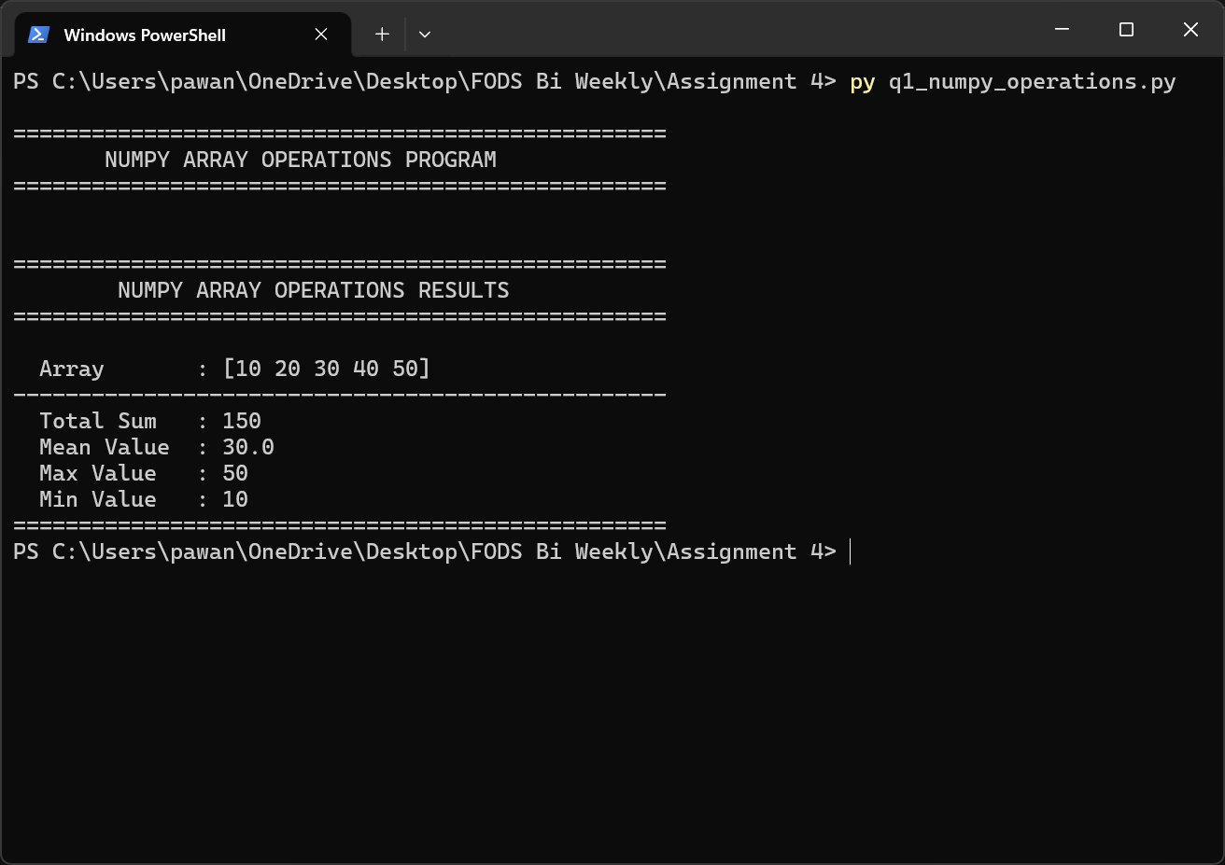
Figure 1.1 – Program 1 console output: array created and all four NumPy operations executed successfully.

Expected Output Verification:
For the array [10, 20, 30, 40, 50], the mathematically correct results are: Total Sum = 150, Mean = 30.0, Max = 50, Min = 10. The screenshot confirms these values are produced correctly.

Program 2: List Sorting & Slicing

2.1 Program Description

Program 2 (q2_list-slicing.py) asks the user to input at least 12 numbers, sorts the list obtained, and then cuts three slices of the sorted list at given index ranges.

Key Functionality:

Asks the user to type in at least 12 numbers spaced out.

Checks input: rejects empty input, non-numeric input and list containing less than 12 items.

Orders the list in ascending order with Python built-in sorted ( ) function.

Extracts slice Index 3–6 (elements at positions 3, 4, 5, 6).

Extracts slice Index 6–9 (elements at positions 6, 7, 8, 9).

Extracts slice Index 4-10 (elements at positions 4-10).

Shows the sorted list and all three slices in a tabular form.

Input Validation:

The get_number_list() function uses a loop of retries. It accommodates empty input, non-numeric tokens (display an error message), and less than 12 elements in the input and alerts the user of the precise issue and re-prompts.

2.2 Testing Screenshots
The screenshot below shows Program 2 in action. The user entered 12 numbers, the program sorted them, and the three slice results are displayed.
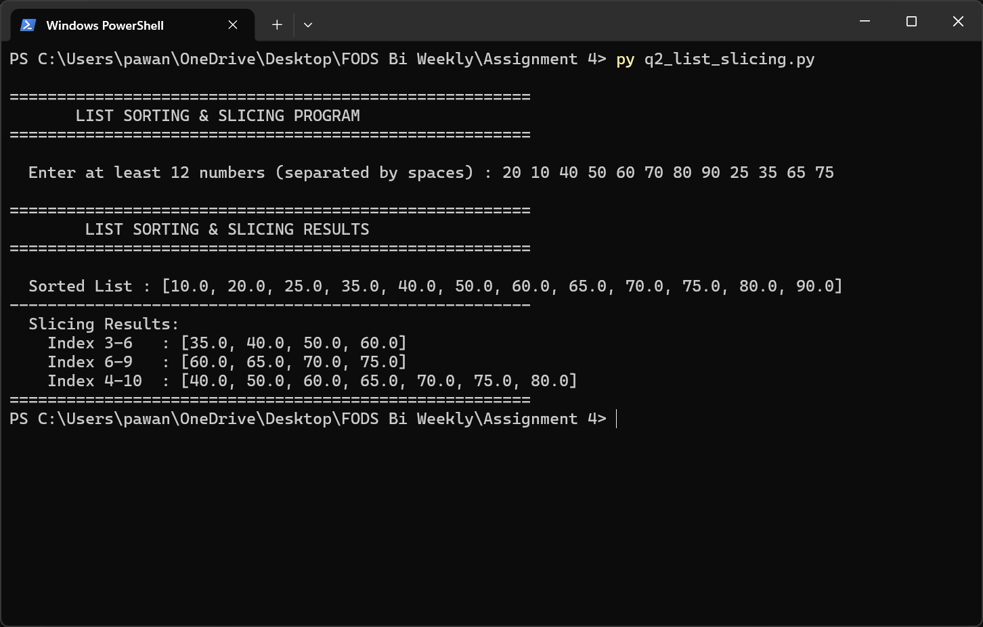
Figure 2.1 – Program 2 console output: 12 user-provided numbers sorted and three index slices extracted and displayed.

Program 3: Array Generate, Sort & Reshape

3.1 Program Description
Program 3 (q3_array_reshape.py) automatically creates a NumPy array consisting of 12 random integers, sorts the array in increasing order, and then reshapes the array in to a 3 x 4 matrix which is then displayed.
Key Functionality:
- The code: Generates 12 random numbers between [0, 100) with the help of np.random.randint.
- sorts the array generated in increasing order by using np.sort.
- Reformats the 1D sorted array into a 2D matrix of size 3x 4 with help of.reshape(3, 4).
- Shows the initial (unsorted) array, the sorted array, and the reshaped 3x4 array.
- Each run generates a set of random numbers which is unique, indicating dynamic behaviour.

Design Notes:
The program involves three distinctly separated functions: generate random array(size parameter is set to 12 default), sort array and reshape array(row/col parameter is set to 3 and 4). The shape and structure of the output is important, as the screenshot will vary on each run due to the use of random values.

3.2 Testing Screenshots
The screenshot below shows one execution of Program 3. The original randomly generated array, the sorted version, and the reshaped 3×4 matrix are all visible.
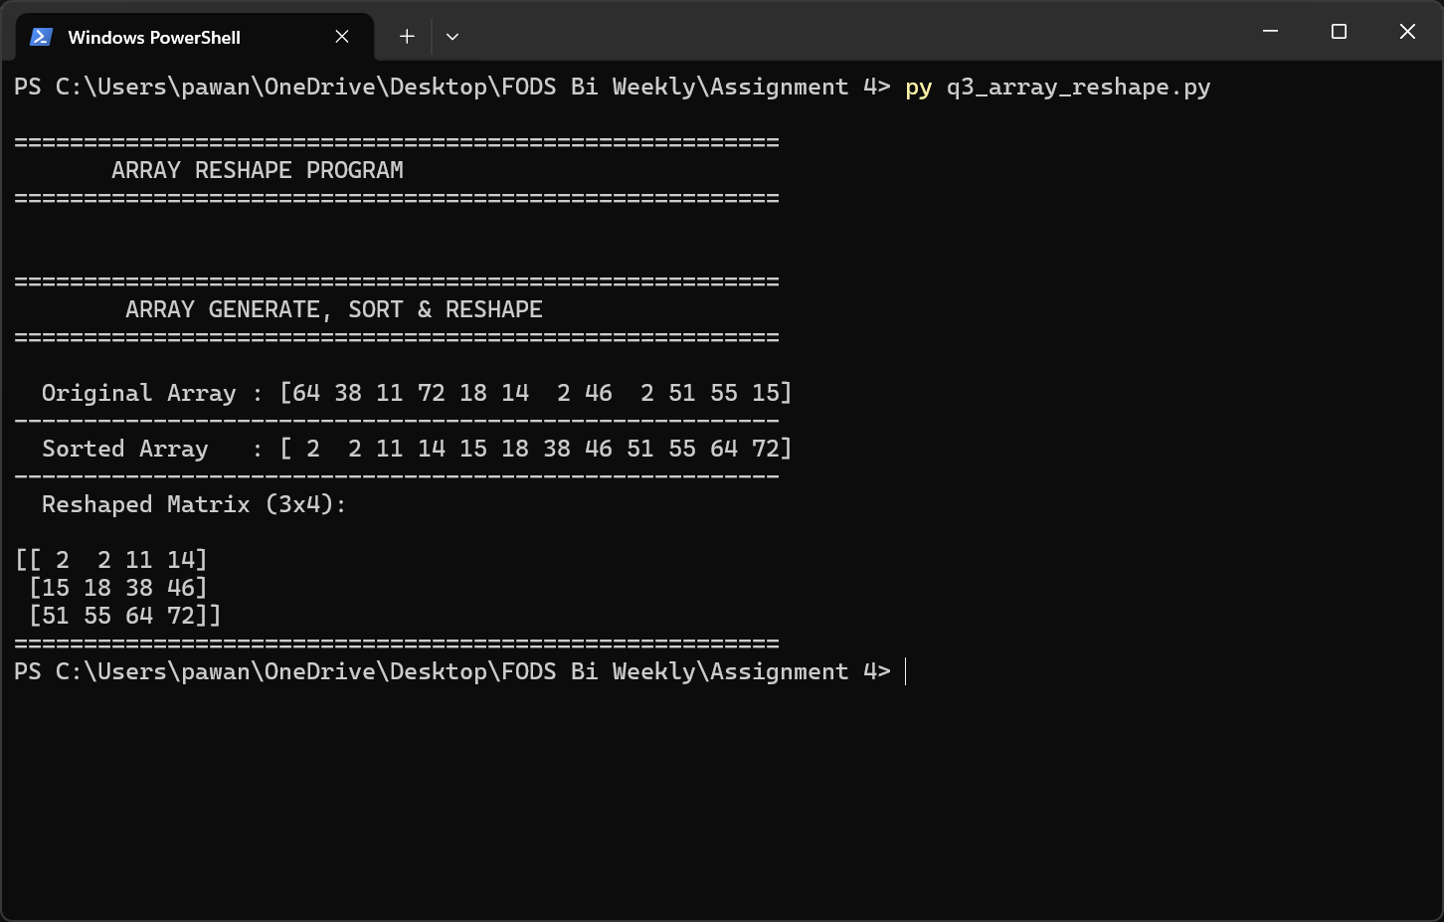
Figure 3.1 – Program 3 console output: 12 random integers generated, sorted, and reshaped into a 3×4 matrix.

Program 4: Matrix Operations

4.1 Program Description

Program 4 (q4_matrix operations.py) is a calculator of matrices. Two matrices that are of similar size are entered by the user, and the program adds, subtracts and multiplies with NumPy with full dimension checks and custom exception management.

Key Functionality:

Asks the user to input the number of rows and number of columns of Matrix A and Matrix B.

Allows entry of elements row by row and is validated (proper number of elements per row, only numeric values).

Checks that the two matrices are the same size then adds and subtracts.

Checks that rows of A are equal to rows of B and then multiplies.

Throws a custom DimensionMismatchError exception in case dimension constraints are violated.

Shows Matrix A, Matrix B and addition, subtraction and multiplication results.

Exception Handling:

A special DimensionMismatchError (Exception) class has descriptive error messages. Checks of addition/subtraction dimensions are first followed by multiplication checks, so the program can tell exactly which operation failed.

4.2 Testing Screenshots
The screenshot below demonstrates Program 4 with two compatible matrices. Both matrices are entered by the user, and all three operations (addition, subtraction, multiplication) are performed and displayed.
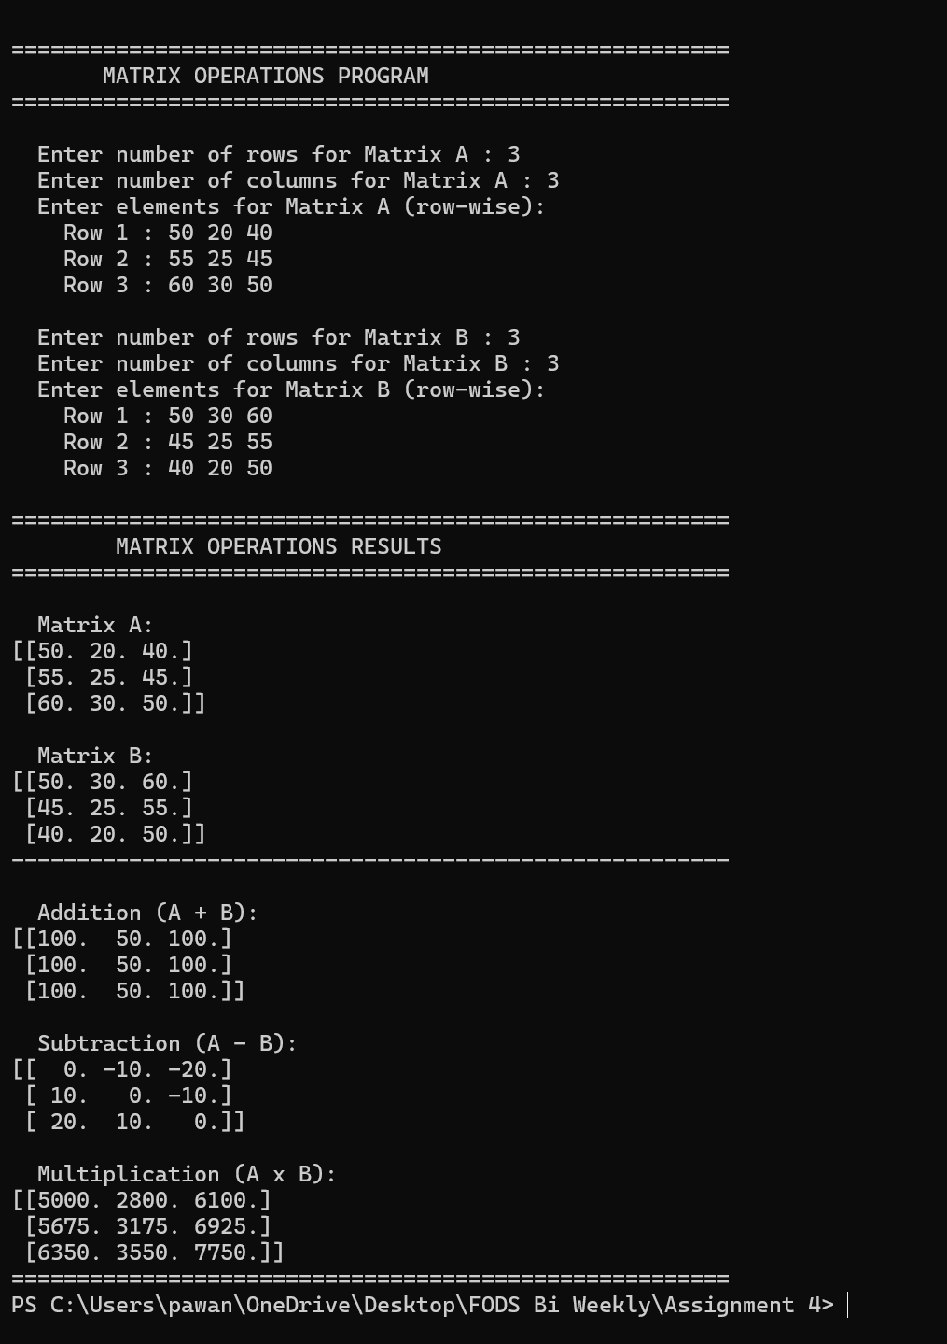
Figure 4.1 – Program 4 console output: two matrices entered interactively; addition, subtraction, and multiplication results displayed.

Program 5: Health Data Visualization

5.1 Program Description
The program 5 (q5_health_visualization.py) loads health data (health_data.csv) in a CSV file with Pandas and creates five scatter plots with Matplotlib to investigate the correlation of health variables such as weight, height, age, and gender.
Key Functionality:
Loads health_data.csv into a Pandas DataFrame and validates that required columns (Weight, Height, Age, Gender) exist.
Categorizes the nominal Gender column with numeric codes (0/1) to allow it to be plotted on a scatter plot.
Plot 1: Weight vs. Height (blue scatter) generated.
Produces Plot 2: Age against weight (green scatter).
Plot 3: Height vs. Age (red scatter) generated. • Plot 4 Gender vs. Height (purple scatter 0 = Female, 1 = Male).
Plot 5 Gender vs. Weight (orange scatter) is generated.
Shows all the five plots in one 2x3 grid (18x10 inches) with labeled axises and titles.

Input Data:
The health records are five in the CSV file and they have the following columns: Name, Age, Weight (kg), Height (m), and Gender. The following screenshot is the original CSV data loaded into the program.

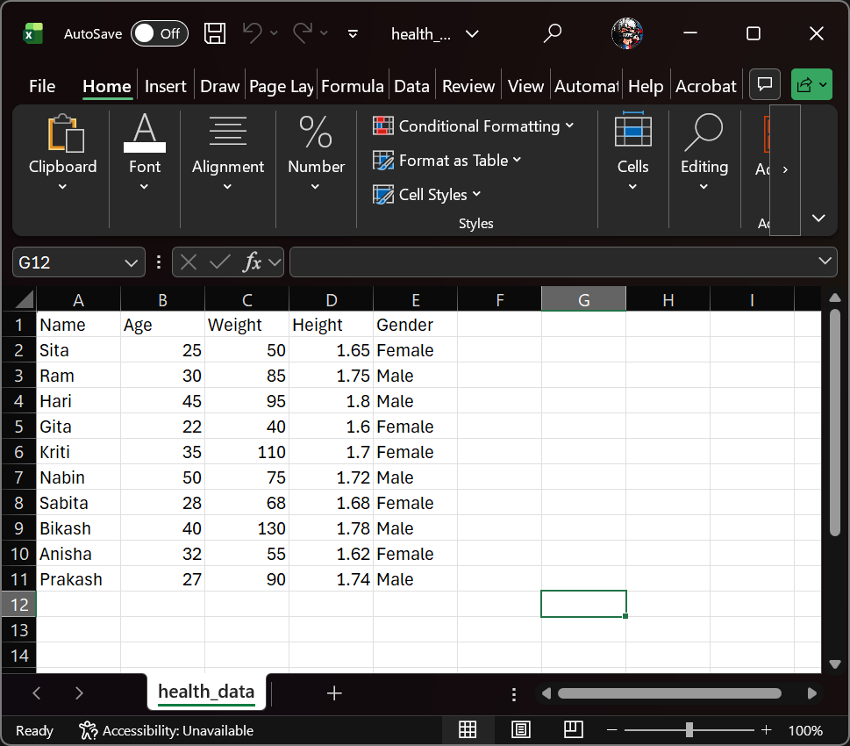
Figure 5.1 – Original health_data.csv loaded in the execution environment, showing the five patient records used by Programs 5 and 6.

5.2 Testing Screenshots
Console Output
The screenshot below shows the program's console output, confirming data load success and listing the five plots being generated.
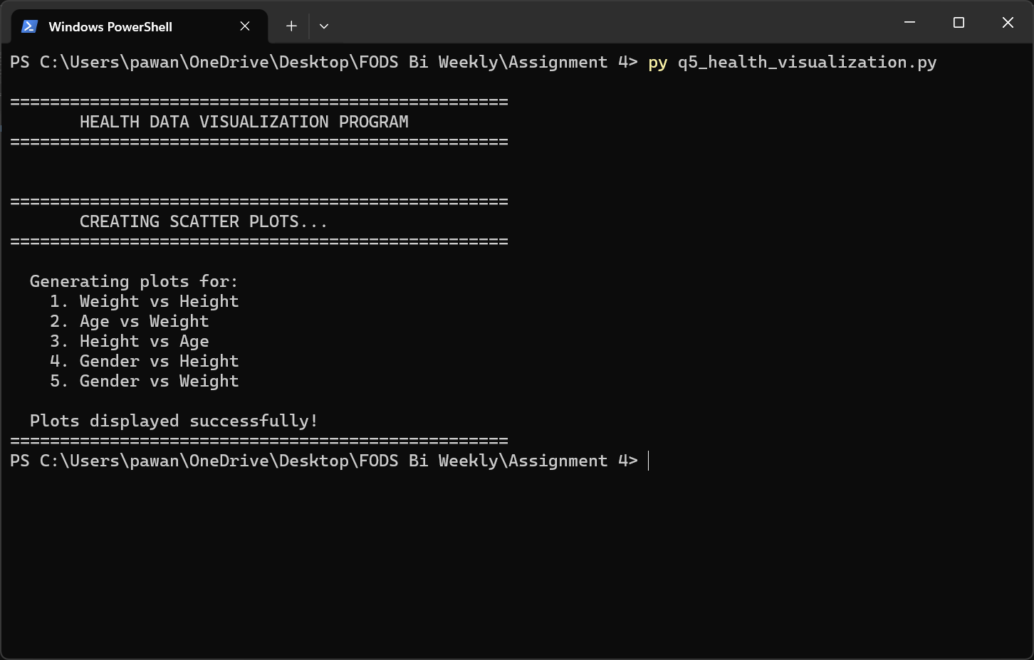
Figure 5.2 – Program 5 terminal output: data loaded, five scatter plots listed, and plots displayed successfully.
Visualization Output
The screenshot below shows the five scatter plots generated by Matplotlib, displayed in a 2×3 grid. Each subplot has labeled axes and a descriptive title. Note that the Gender encoding is shown in the axis label (0 = Female, 1 = Male).
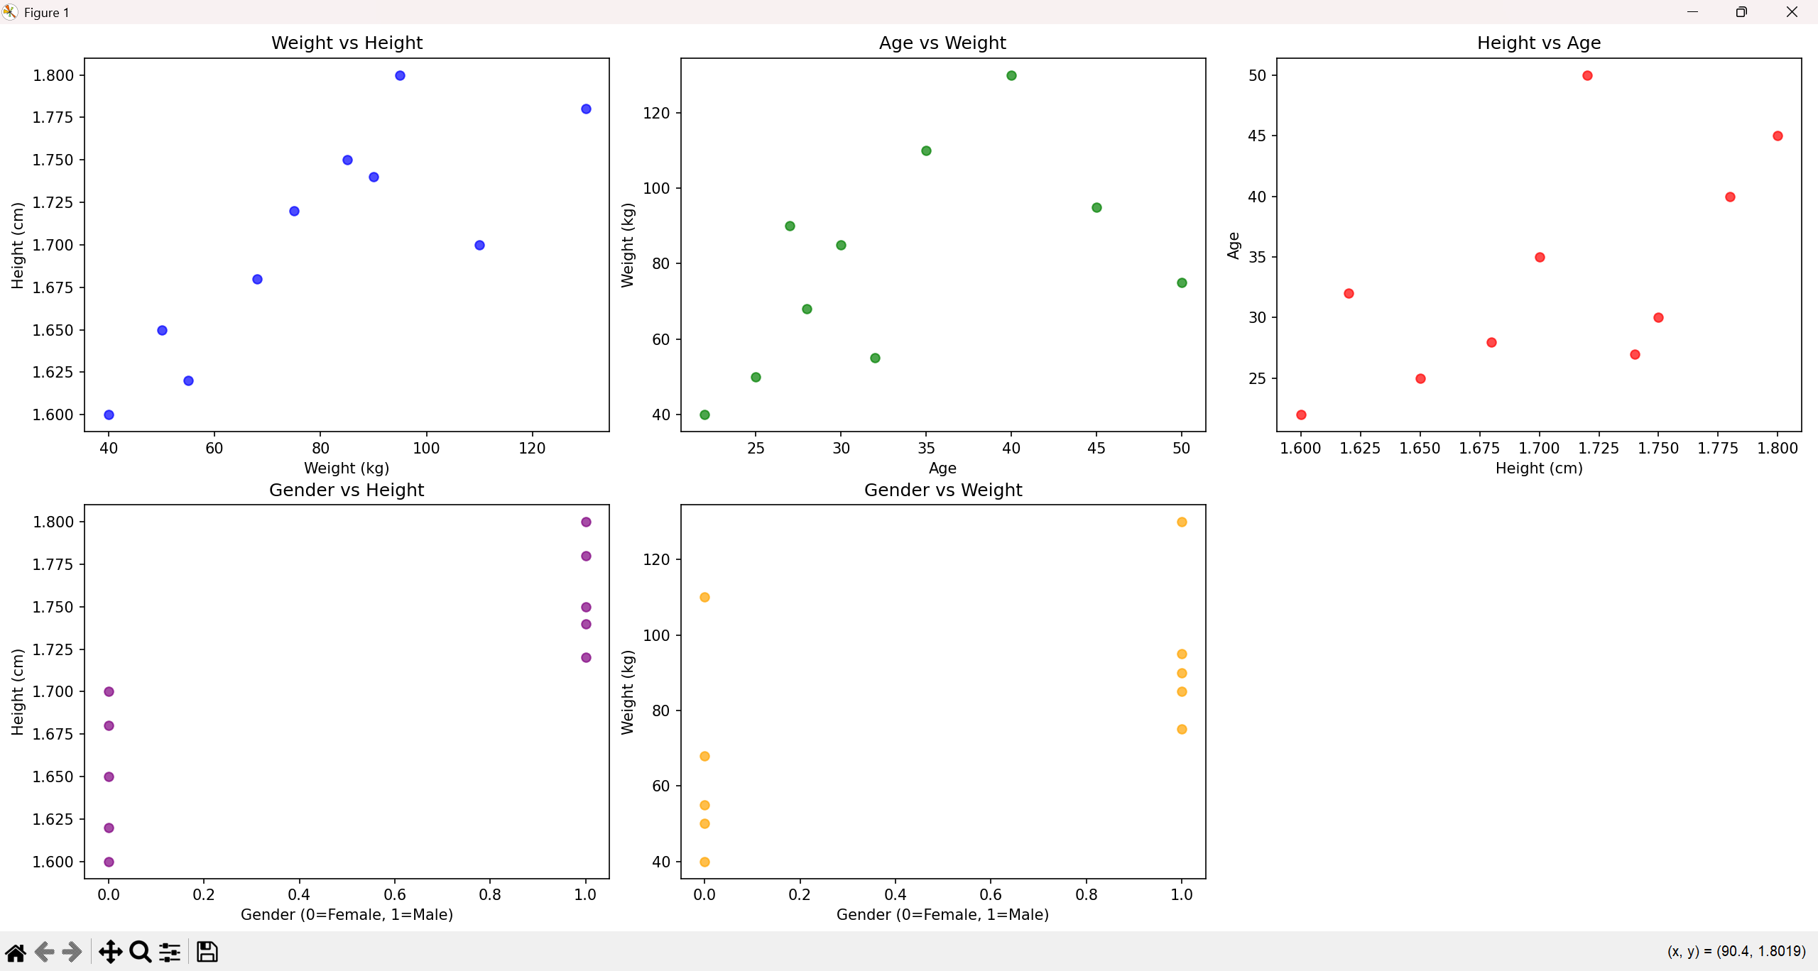
Figure 5.3 – Program 5 scatter plots: five relationship visualizations generated from health_data.csv (Weight vs Height, Age vs Weight, Height vs Age, Gender vs Height, Gender vs Weight).

Program 6: BMI & Health Status Analyzer

6.1 Program Description
The same health_data.csv is read by program 6 (q6_bmi_analysis.py), which adds two new columns derived on it: BMI (Body Mass Index) and Health_Status. The new DataFrame is not only presented on the screen, but also stored in the health-data-updated.csv.

Key Functionality:
- Loads health_data.csv and confirms that there are columns of Weight and Height.
- Calculates BMI for each person using the formula: BMI = Weight / Height² (rounded to 2 decimal places).
- Categorizes all BMI by a multi-tier scale into a Health_Status category.
- Shows the original DataFrame (without BMI columns) to compare. • Shows the modified DataFrame containing the two new columns added.
- Print summary statistics: Count of Health Status distribution, minimum BMI, maximum BMI and mean.
- Saves the edited DataFrame as health data updated.csv.

BMI Classification Scale:
BMI Range | Health Status
< 18.5 | Underweight
18.5 – 24.9 | Healthy range
25.0 – 29.9 | Overweight risk
30.0 – 34.9 | High risk (diabetes/heart disease)
35.0 – 39.9 | High risk (diabetes/heart disease)
≥ 40.0 | Critical health condition

6.2 Testing Screenshots
Original vs. Updated DataFrame
The screenshot below shows both the original DataFrame (top) and the updated DataFrame with the new BMI and Health_Status columns appended (bottom).
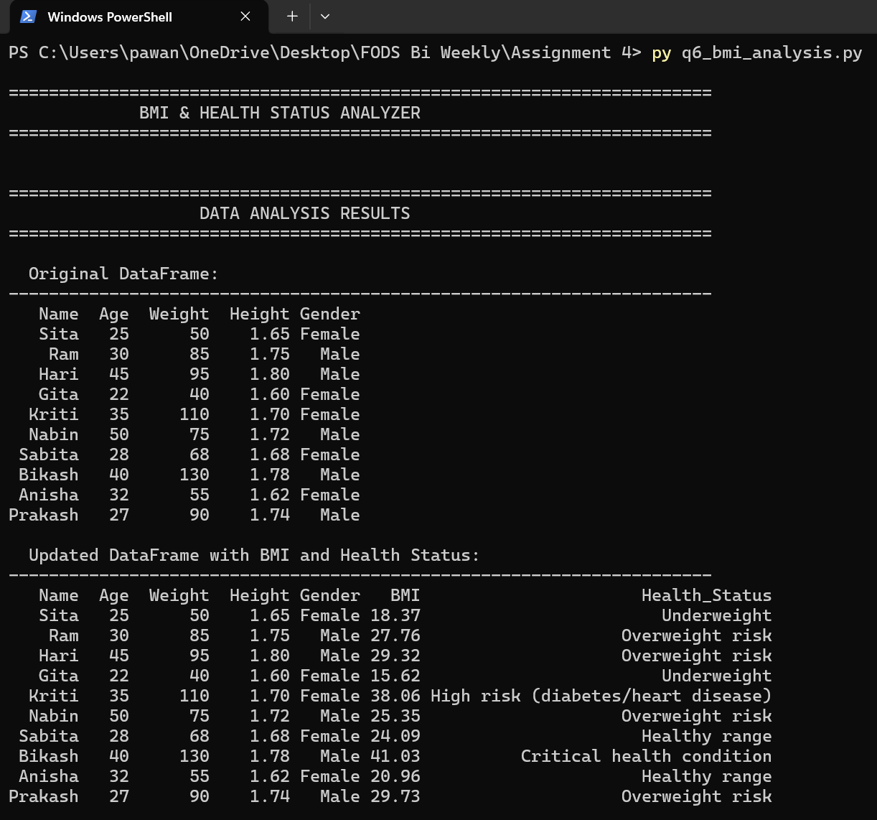
Figure 6.1 – Program 6: original DataFrame (top) and updated DataFrame with BMI and Health_Status columns (bottom).
Updated Data Detail
The screenshot below focuses on the updated DataFrame showing the full BMI and Health_Status values for all five records.
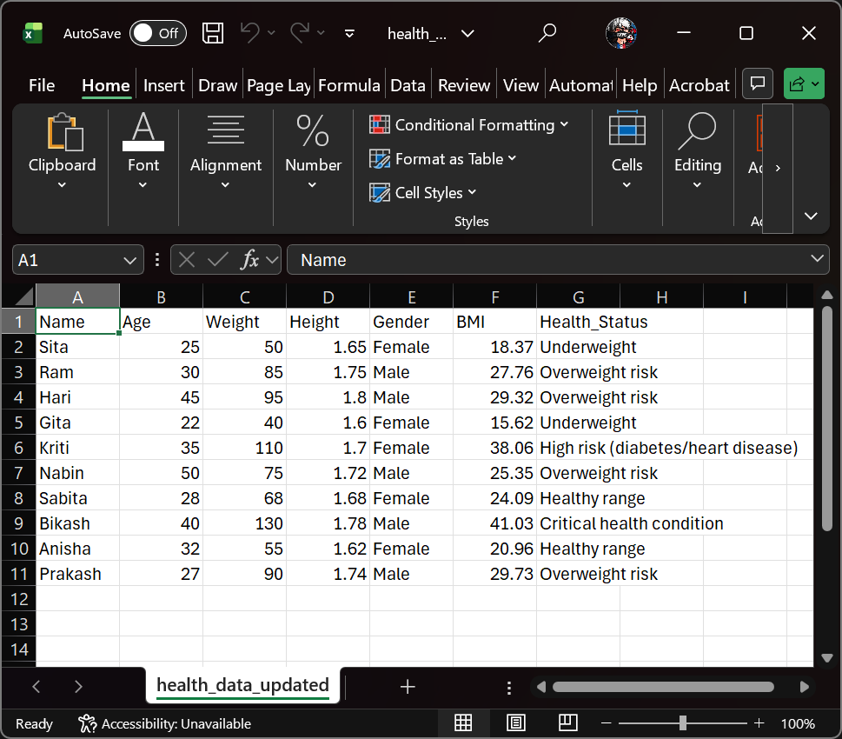
Figure 6.2 – Program 6: updated health_data DataFrame with calculated BMI and classified Health_Status for all records.
Summary Statistics
The screenshot below shows the summary statistics section: Health Status distribution (count per category) and the minimum, maximum, and mean BMI values across the dataset.
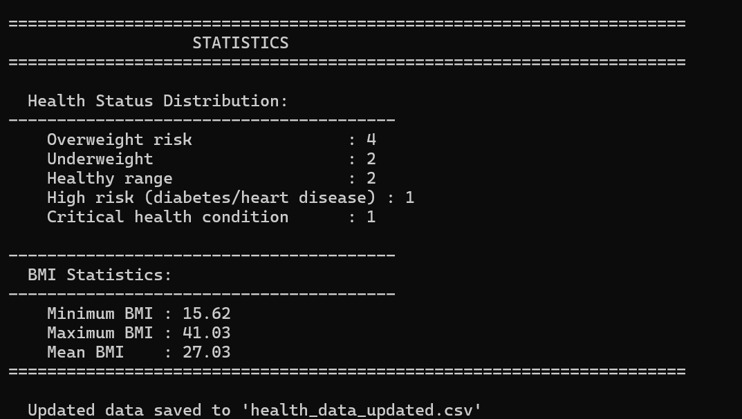
Figure 6.3 – Program 6: Health Status distribution counts and BMI statistics (min, max, mean).

End of Documentation

